**NAME:AKSHITA JASORIA**

**Aim:** Basic commands in networking

**Outcome:** To Explain fundamentals of computer networks

**Theory:**

hostname: used to find out hostname

getmac-

ipconfig: used to view TCP/IP configuration

ipconfig \all

ping: used to check connection between devices

tracert: To see entire path form our device

nslookup: for DNS name resolution

netstat

arp-a

net view

pathping

route print

**Part B**

**Hostname:** A hostname is a unique name for a computer or network node in a network. Hostnames are specific names or character strings that refer to a host and make it usable for the network and people. They can describe both physical addresses and network nodes, which have multiple domains under one host.

**Getmac-** Getmac is a Windows command used to display the Media Access Control (MAC) addresses for each network adapter in the computer. These activities will show you how to use the getmac command to display MAC addresses.

**Ipconfig-** Displays all current TCP/IP network configuration values and refreshes Dynamic Host Configuration Protocol (DHCP) and Domain Name System (DNS) settings. Used without parameters, ipconfig displays Internet Protocol version 4 (IPv4) and IPv6 addresses, subnet mask, and default gateway for all adapters.

**Ipconfig \all-** ipconfig basically lists out all the IP Configuration details of your Windows based machine. This would include both the Hardware MAC Addresses as well as your IP Address associated with that MAC. It basically lists out all the Networking Adapters in your machine with their MAC, IP, Default Gateway and Subnet Mask.

**Ping:** Ping is a command-line utility, available on virtually any operating system with network connectivity, that acts as a test to see if a networked device is reachable. The ping command sends a request over the network to a specific device.

**tracert:** The tracert command is a Command Prompt command that's used to show several details about the path that a packet takes from the computer or device you're on to whatever destination you specify. You might also sometimes see the tracert command referred to as the trace route command or traceroute command.

**Nslookup:** Nslookup (stands for “Name Server Lookup”) is a useful command for getting information from DNS server. It is a network administration tool for querying the Domain Name System (DNS) to obtain domain name or IP address mapping or any other specific DNS record. It is also used to troubleshoot DNS related problems.

**Netstat-** Netstat (network statistics) is a command line tool for monitoring network connections both incoming and outgoing as well as viewing routing tables, interface statistics etc. netstat is available on all Unix-like Operating Systems and also available on Windows OS as well.

**Arp-a –** To display the ARP table on a Unix system, just type "arp -a" (this same command will show the arp table in the command prompt on a Windows box, by the way). The output from arp -a will list the network interface, target system and physical (MAC) address of each system.

**Net view-** Displays a list of domains, computers, or resources that are being shared by the specified computer. Used without parameters, net view displays a list of computers in your current domain.

**Pathping-** Provides information about network latency and network loss at intermediate hops between a source and destination. This command sends multiple echo Request messages to each router between a source and destination, over a period of time, and then computes results based on the packets returned from each router.

**Route print**- Use the -p option with the add command to make a route persistent. Use the -p option with the print command to view the list of registered persistent routes. The destination specifies the network destination of the route. The destination can be an IP network address, an IP address for a host route, or a default route.

**OUTPUT:**

**Hostname:**



**Getmac-**

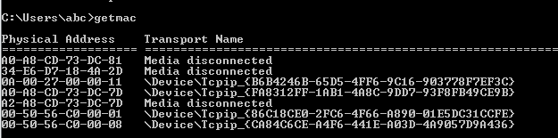

**Ipconfig-**

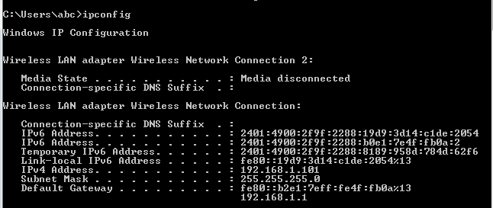

**Ipconfig \all:**

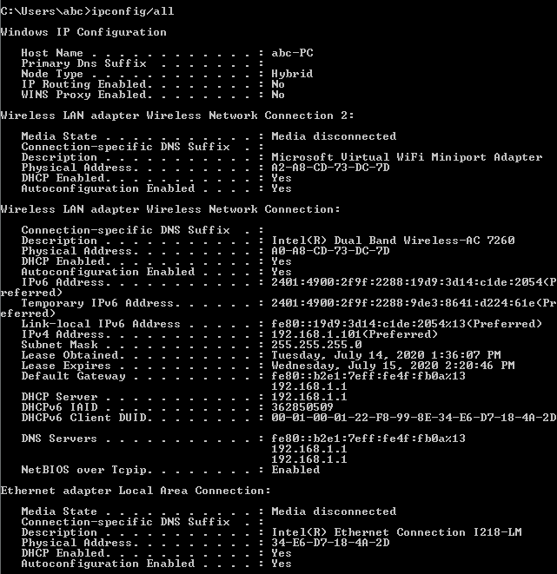

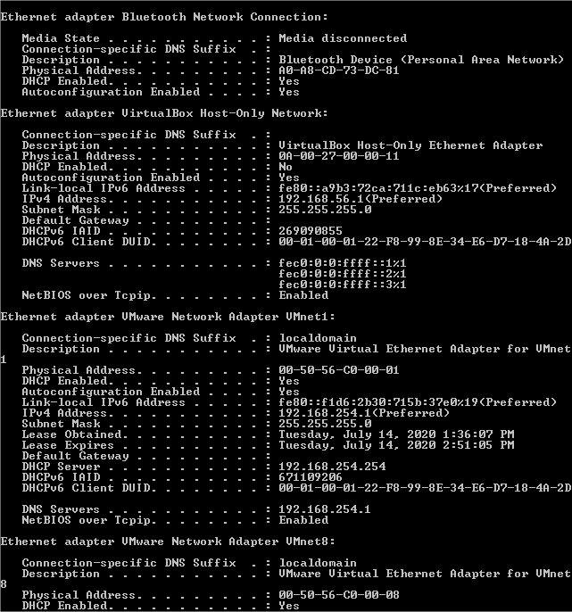

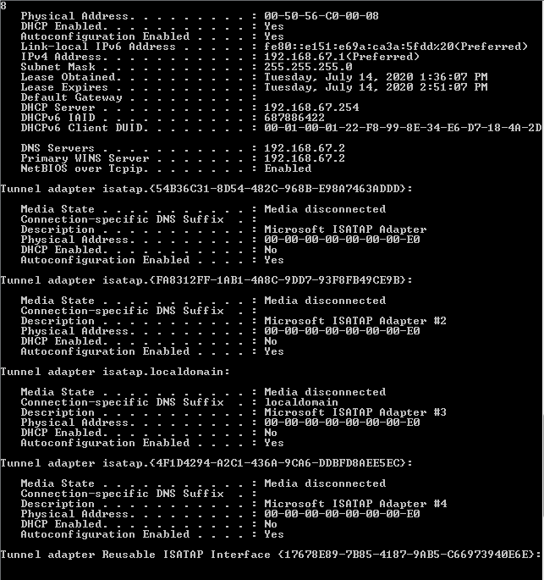

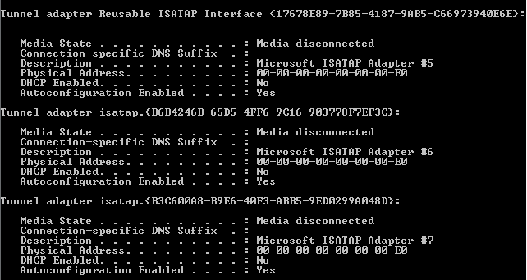

**Ping:**

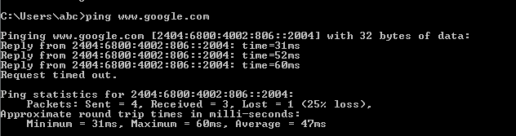

**tracert:**

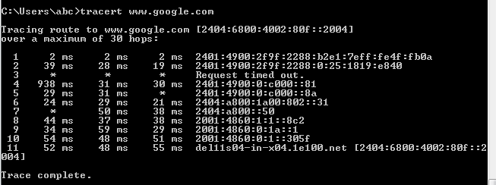

**Nslookup:**

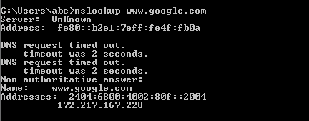

**Netstat-**

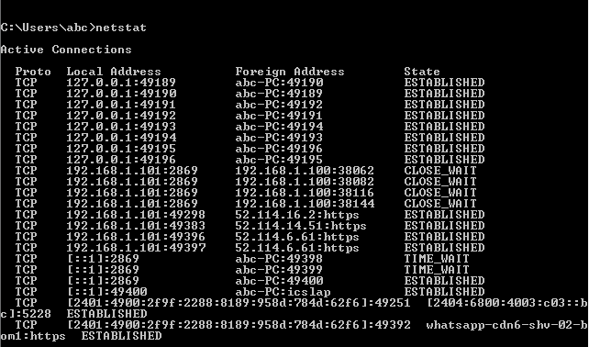

**Arp-a:**

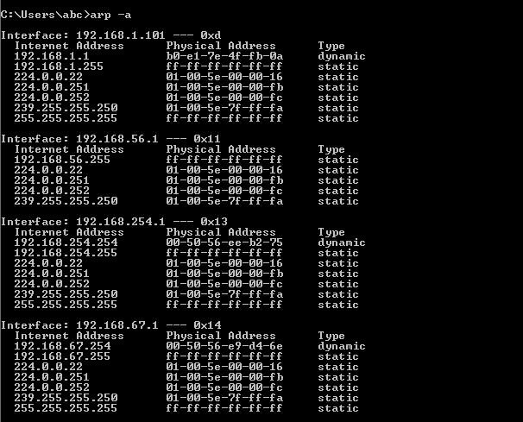

**Net view:**

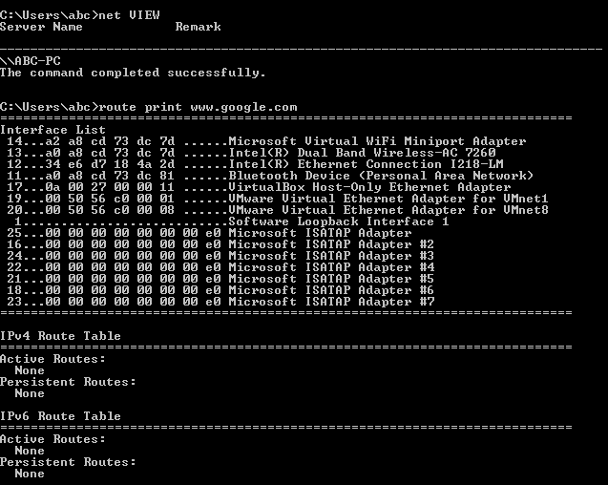

**Pathping:**

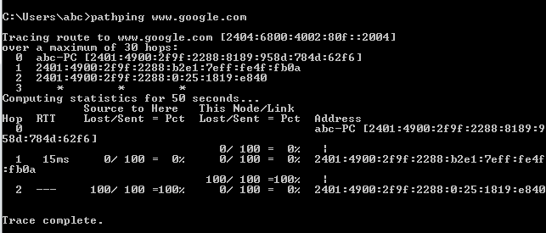

**Route print:**

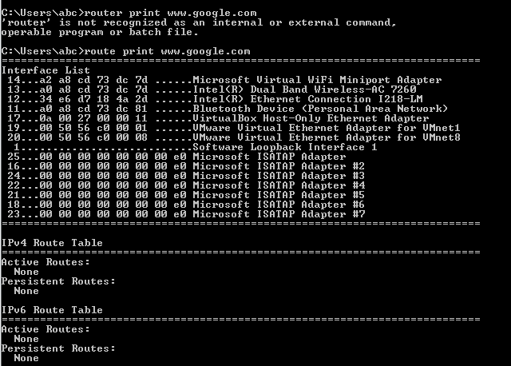

**Questions:**

Q1) what is the hostname of your system



abc-PC

Q2) what is the IP address and Physical address of your system?

Ip address:192.168.1.101

Physical address: A0-A8-CD-73-DC-7D





Q3) what is IP address of next hop



Q4) How many hops takes from your system to reach [www.google.com,which](http://www.google.com,which) command is used to find out this?

Total 11

Q5) What is the use of arp command

The "arp" Command. arp displays and modifies entries in the Address Resolution Protocol (ARP) cache, which contains one or more tables that are used to store IP addresses and their resolved Ethernet or Token Ring physical addresses.